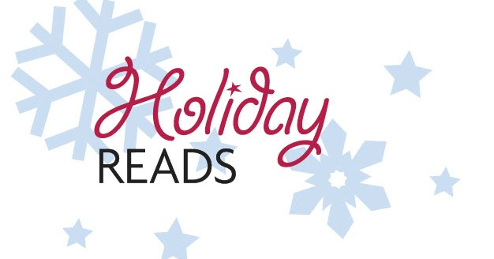

Teen/Adult Holiday Reading Program
Greenville Public Library

The Greenville Public Library invites highschoolers and adults to participate in our first Holiday Reading Program.

Starting November 23rd, read 6 books to enter a drawing to win a $25 gift card to a business in town. We will have two winners. All lists need to be received no later than January 9th, 2021.

Please submit a list of your six books by email (christalv@greenvillepubliclibrary.org), mail, in our drop box, or by appointment. You do not need to have a library account to participate, but you do need access to books. You will have one entry for every 6 books read.

1.______________________________________________________________________
2.______________________________________________________________________
3.______________________________________________________________________
4.______________________________________________________________________
5.______________________________________________________________________
6.______________________________________________________________________
Please include name, phone number, and address with submission. Call 664-3115 for any questions or assistance.

